**GIT ASSIGNMENT BY ABHISHEK KUAR SAH**

**Install GIT & make sure it is added into PATH.**

**Use GIT as local VCS. Steps to follow:**

**1. Create a directory ‘project_dir’ & cd to ‘project_dir’.**

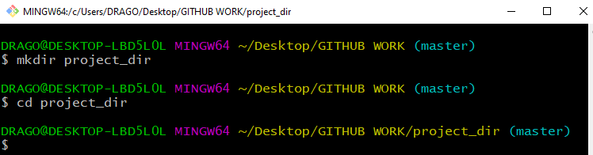

**2. Initialize git version database. (git init)**

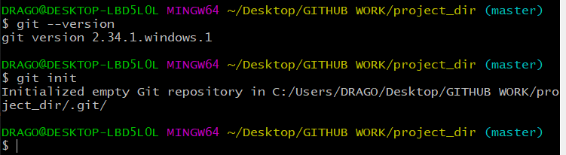

**3. Create a new file index.html.** 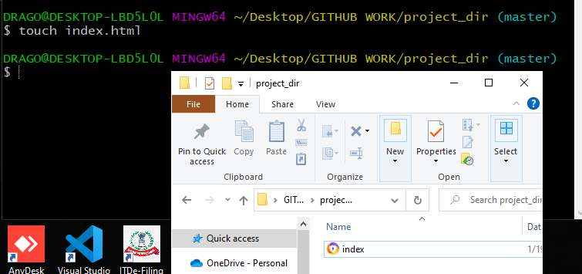

**4. Check the git status. You should find index.html as untracked file.**

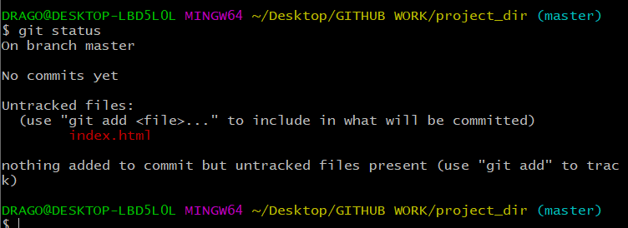

**5. Stage the index.html file.**

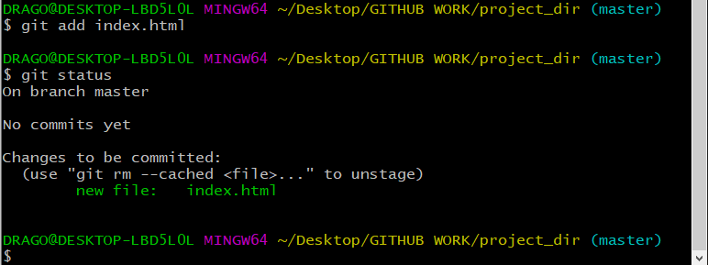

**6. Commit index.html**

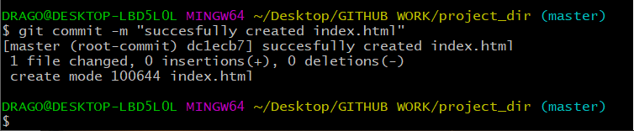

**7. Make few changes in index.html & create a new file info.txt file.**

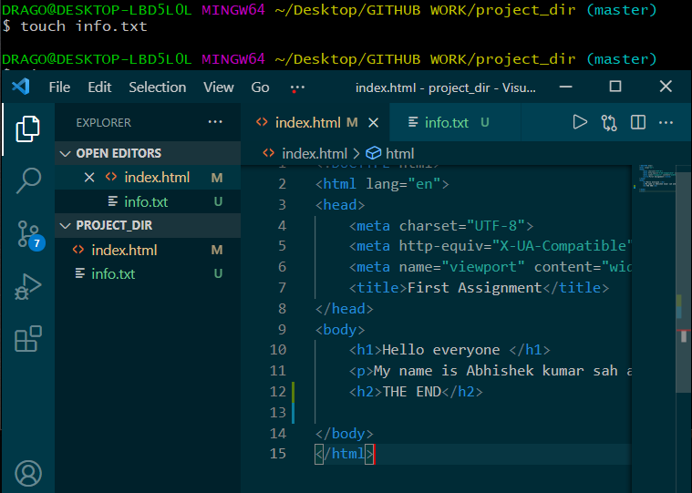

**8. Check git status. You should find index.html & info.txt as untracked files.**

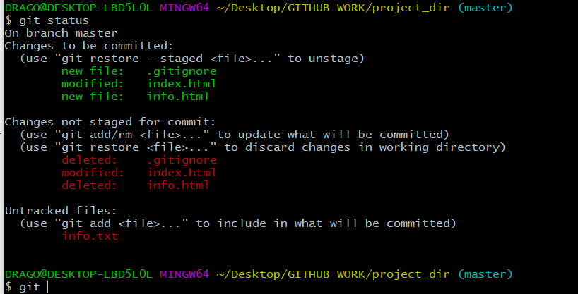

**9. Configure GIT to ignore all txt files.**

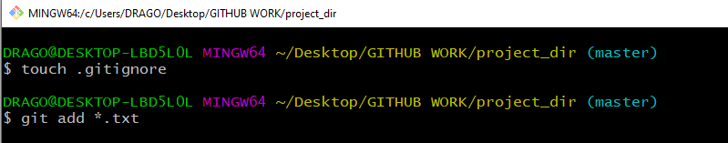

**10. Again check the git status. You should find only index.html as untracked file.**

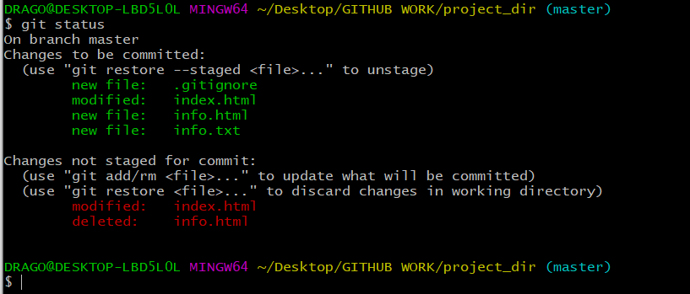

**11. State & commit index.html**

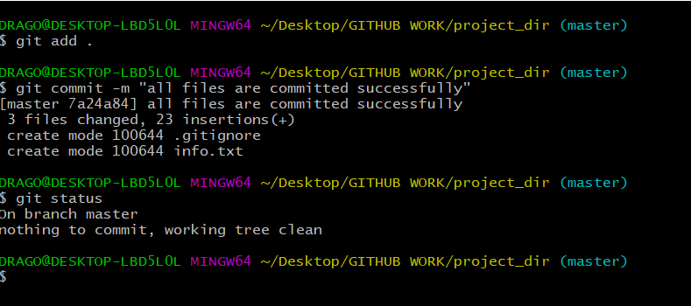

**12. Log all your comments so far.**

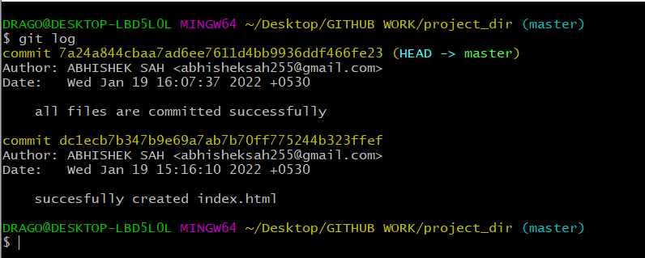

**13. Make some changes in index.html.**

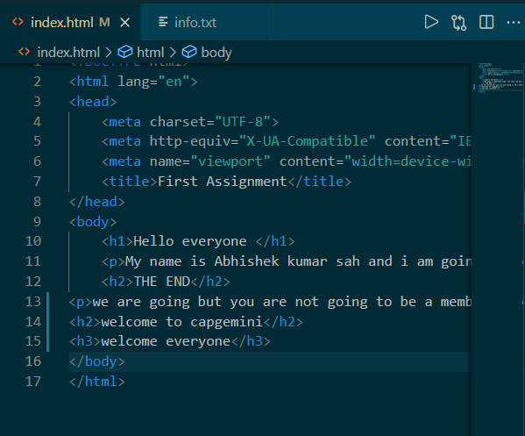

**14. Revert the change made in the previous step using git command.**

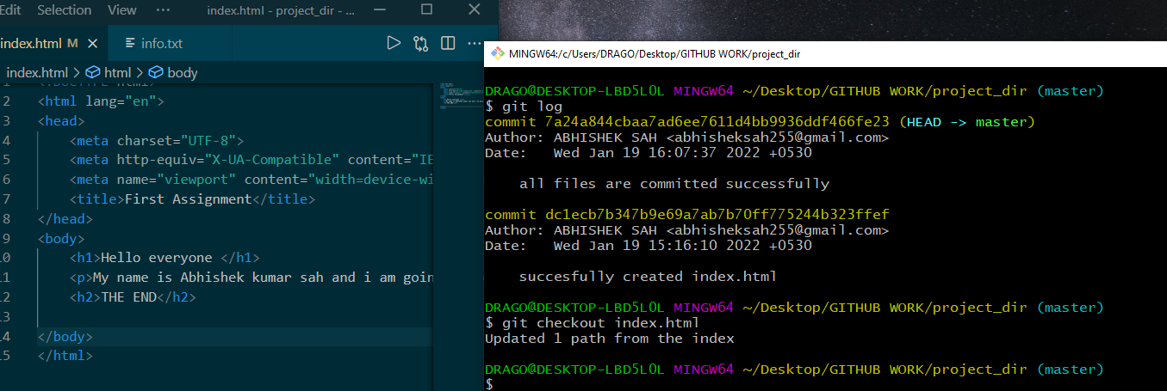

**15. Again change index.html.**

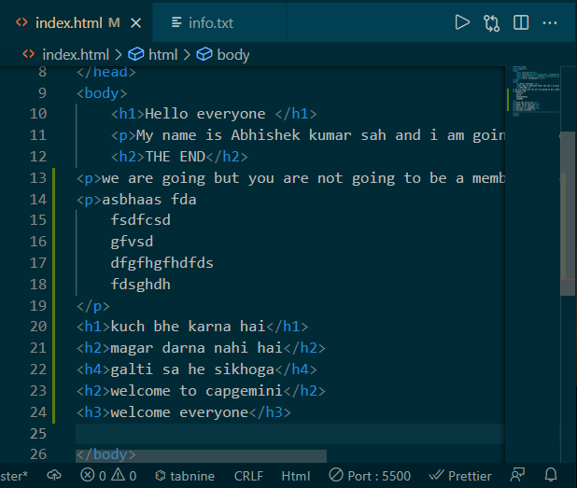

**16. Stage index.html**

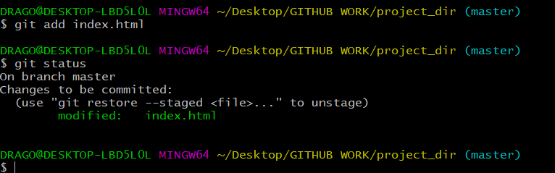

**17. Revert back the last stage.**

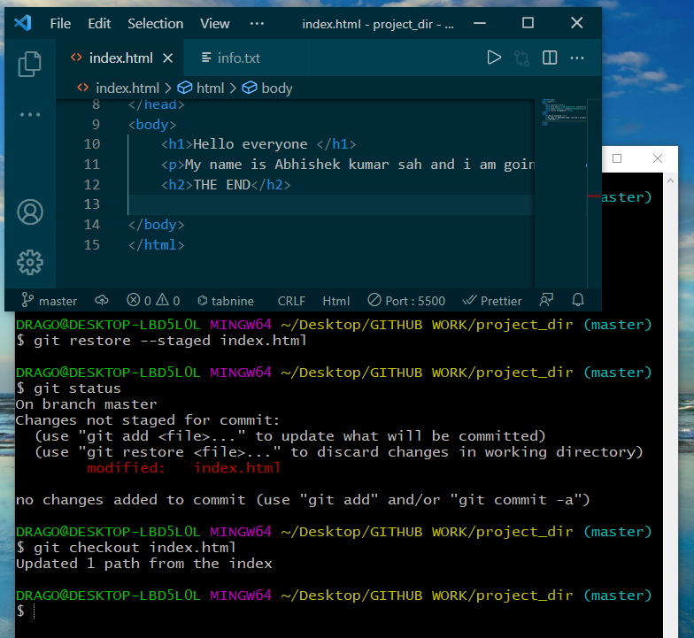

**18. Rename ‘add’ command to ‘my-add’.**



**19. Using my_add command Stage index.html again & commit the changes.**

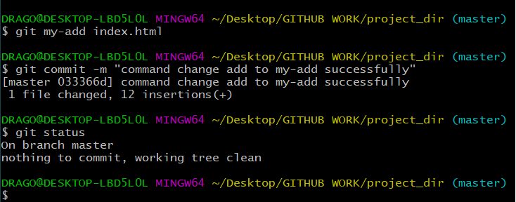

**20. Revert the last commit.**

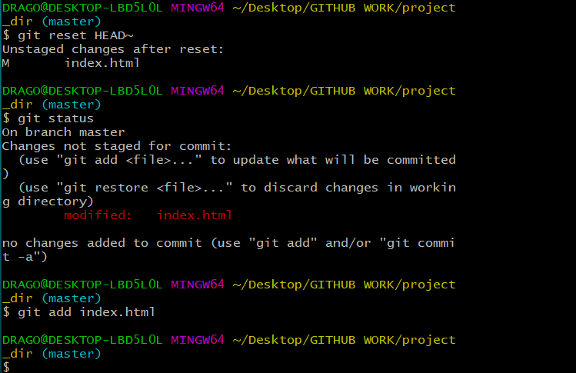

***GIT Branching***

**Objective: Commit HTML, CSS & JavaScript assignments into GIT.**

**SECTION-1 (HTML assignments) - Steps to follow:**

**21. First take a backup of your assignments & projects. This is required because due to incorrect GIT operation you may lose your files.**

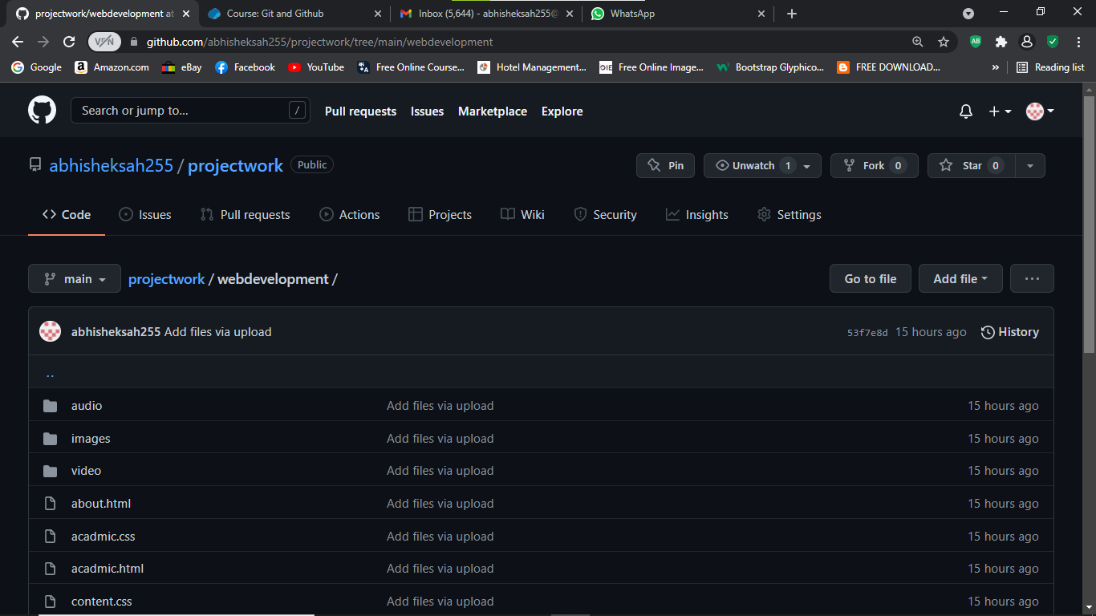

**22. Create an empty directory ‘Assignments’ & cd to ‘Assignments’.**

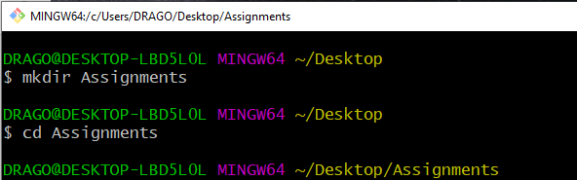

**23. Create a file README.txt inside ‘Assignments’ & write few lines about the contents of ‘Assignments’ folder.**

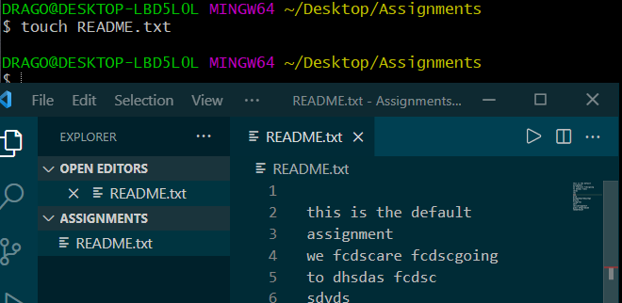

**24. Commit README.txt file.**

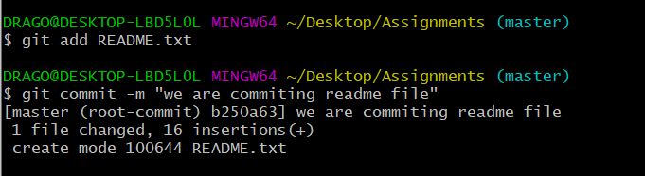

**25. Now create a new branch ‘html-assignments’.**

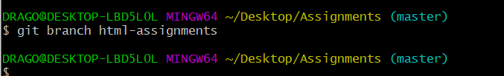

**26. Switch to ‘html-assignments’ branch.**

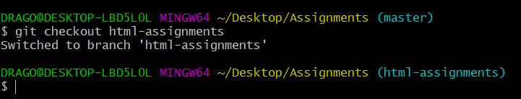

**27. Copy all HTML assignments inside ‘Assignments’ folder.**

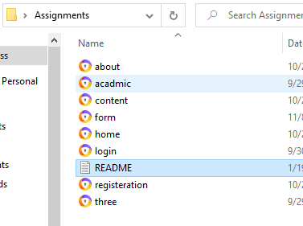

**28. Commit HTML assignments into ‘html-assignments’ branch.**

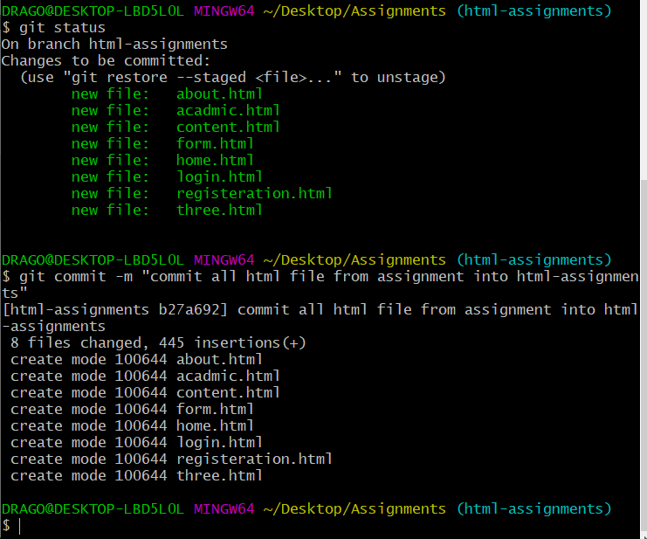

**29. Make minor changes into few files belonging to ‘html-assignments’ branch.**

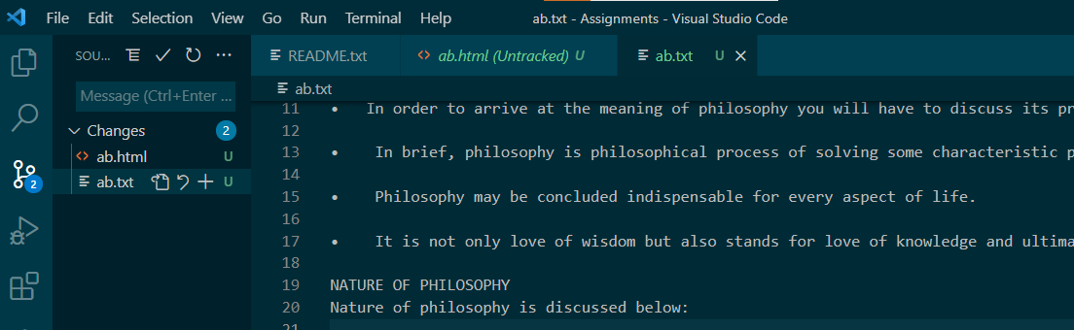

**30. Commit those changed files.**

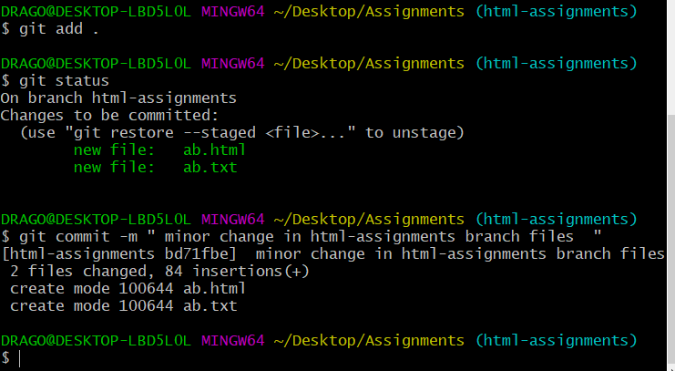

**31. Switch to master branch.**

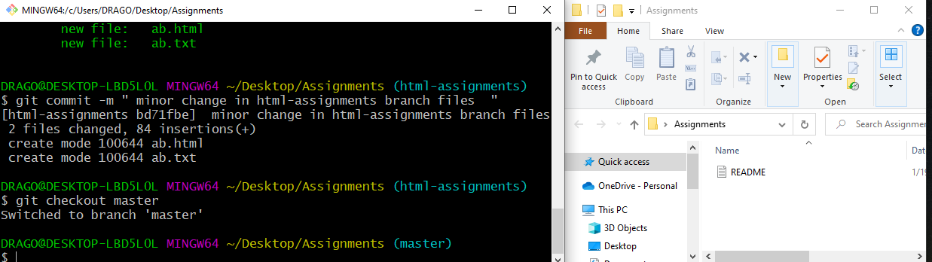

**32. Make minor changes into README.txt file & commit those changes into master.**

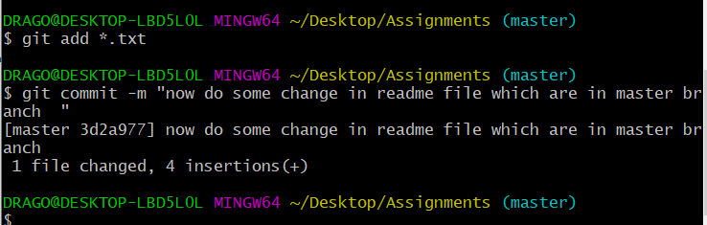

**33. Again switch to ‘html-assignments’ branch.**

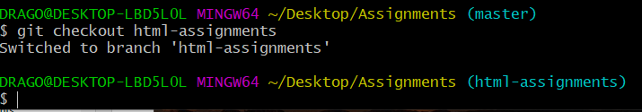

**34. Make minor changes into few files belonging to ‘html-assignments’ branch.**

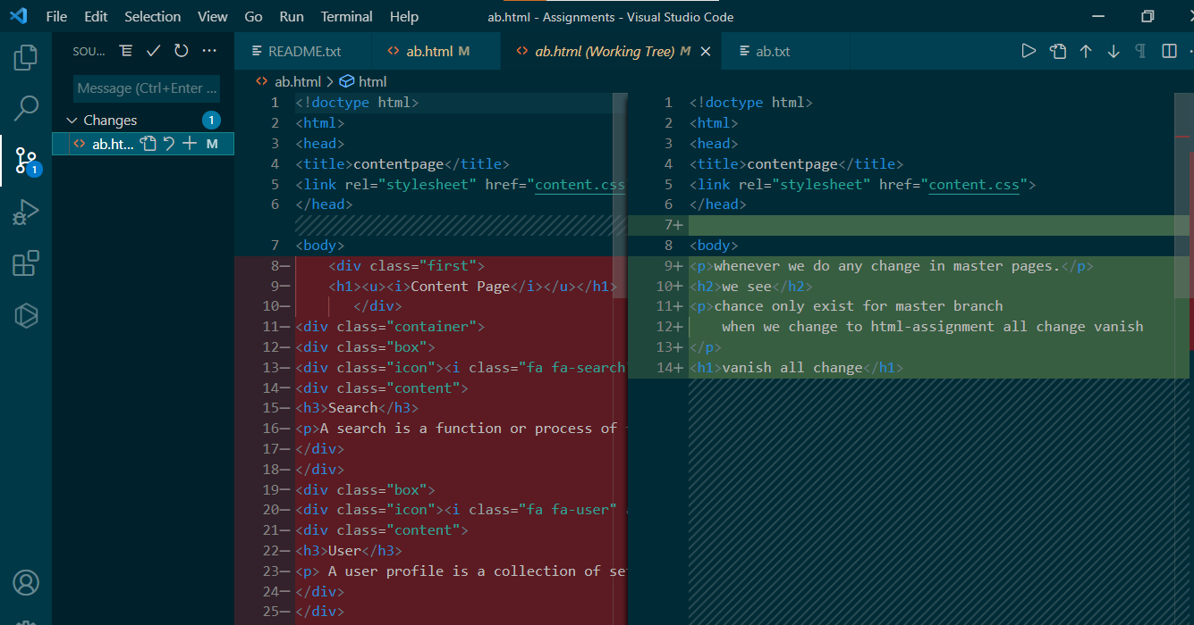

**35. Commit those changes.**

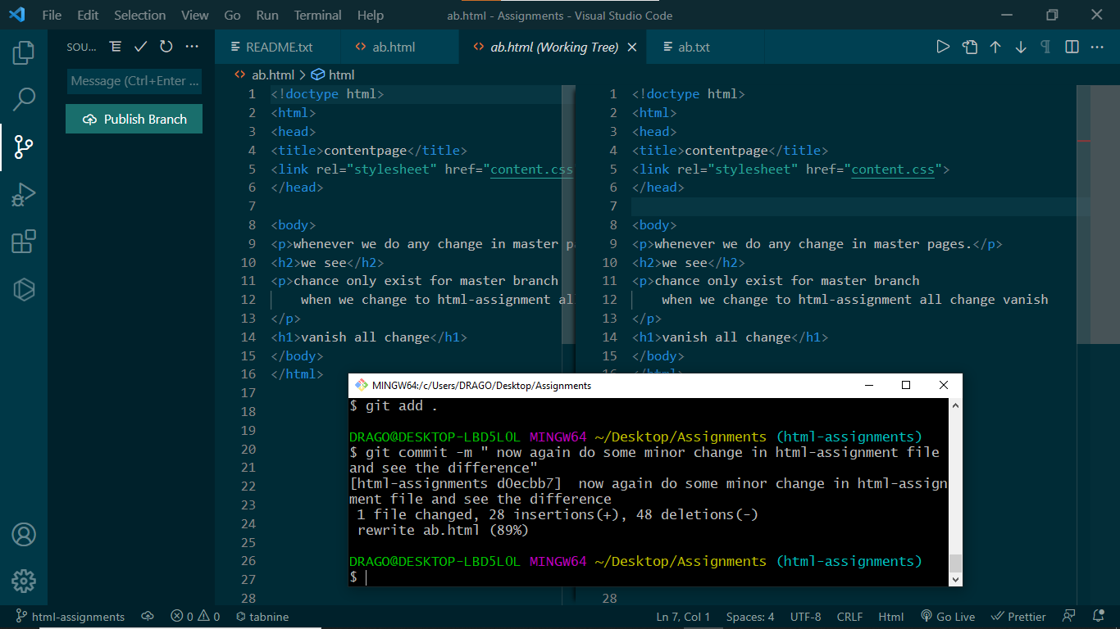

**36. Switch to master.**

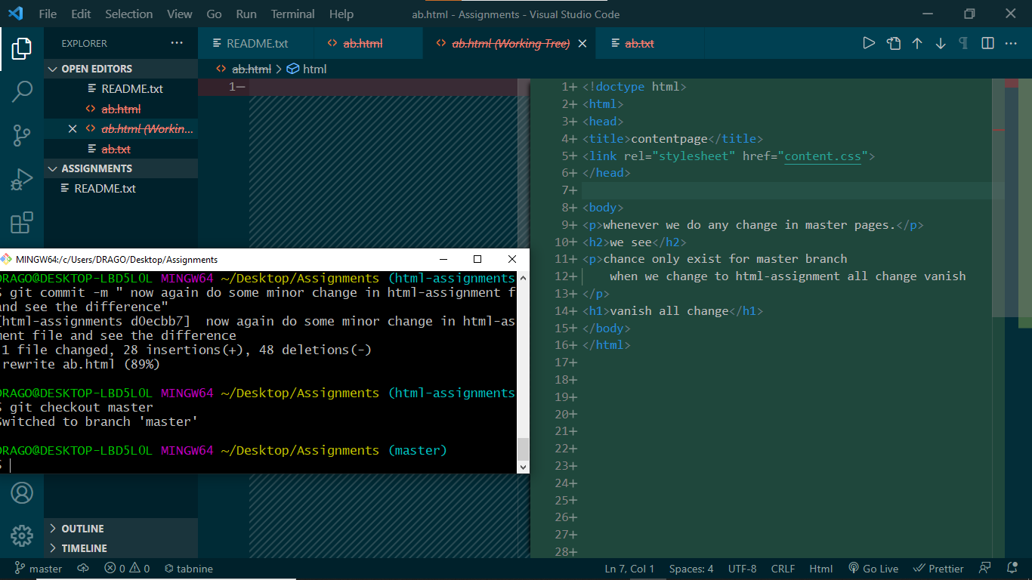

**37. Merge ‘html-assignments’ branch into master. Confirm all html assignments are shown in master.**

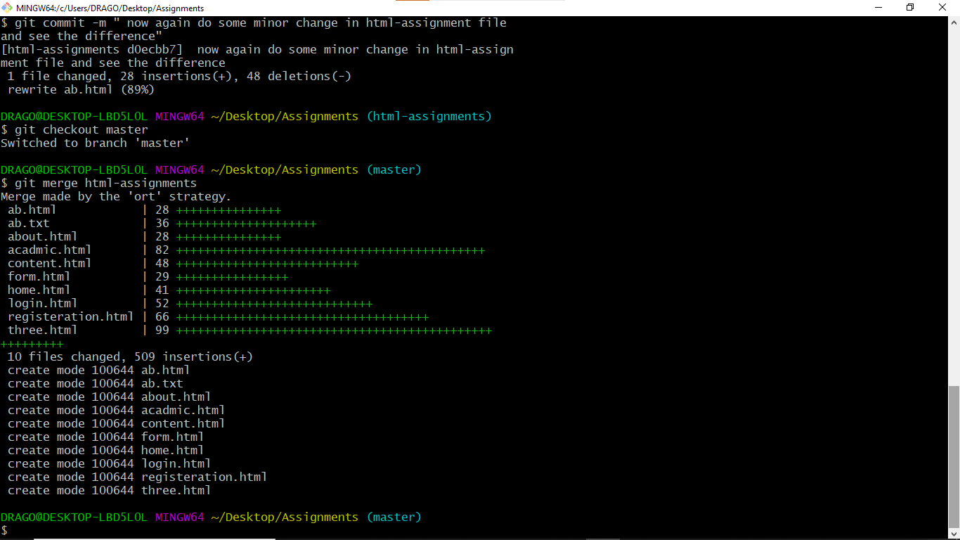

**38. Finally delete the ‘html-assignments’ branch.**

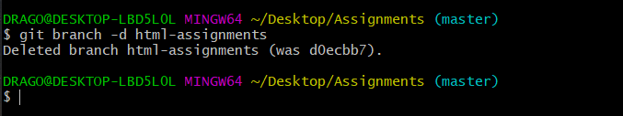

**SECTION-2 - (CSS assignments) Steps to follow:**

**1. Create a new branch ‘css-assignments’.**

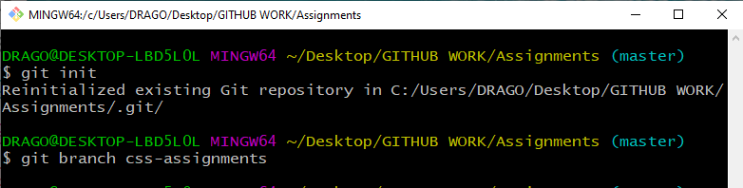

**2. Switch to ‘css-assignments’ branch.**

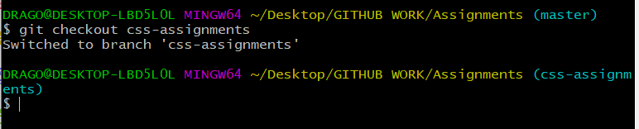

**3. Copy all CSS assignments inside ‘Assignments’ folder.**

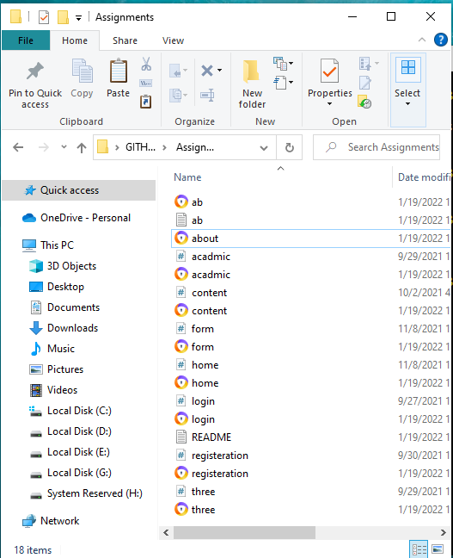

**4. Commit CSS assignments into ‘css-assignments’ branch.**

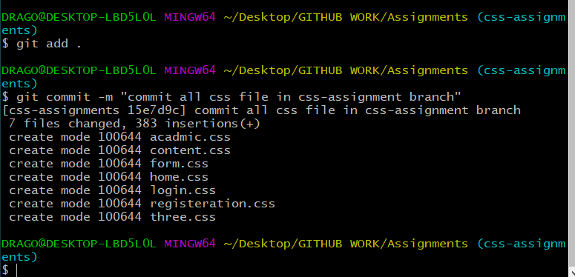

**5. Make minor changes into README.txt file on line 1 belonging to ‘css-assignments’ branch.**

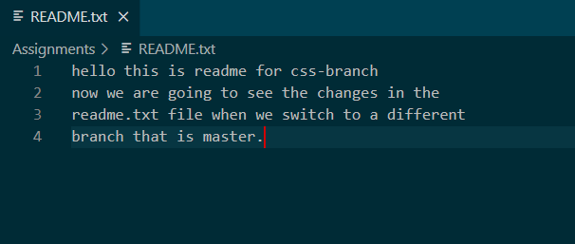

**6. Commit those changed files.**

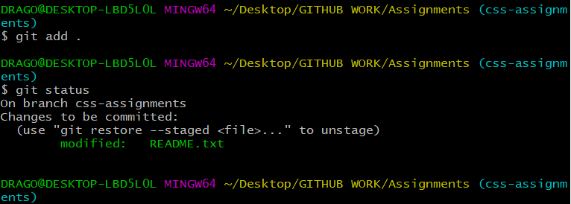

**7. Switch to master branch.**

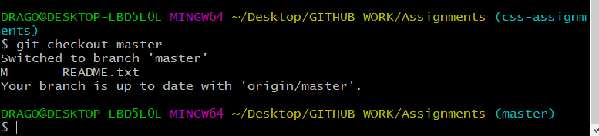

**8. Make minor changes into README.txt file on line 3 & commit those changes into master.**

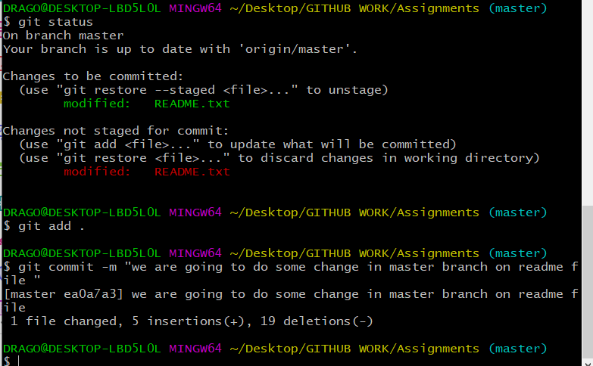

**9. Again switch to ‘css-assignments’ branch.**

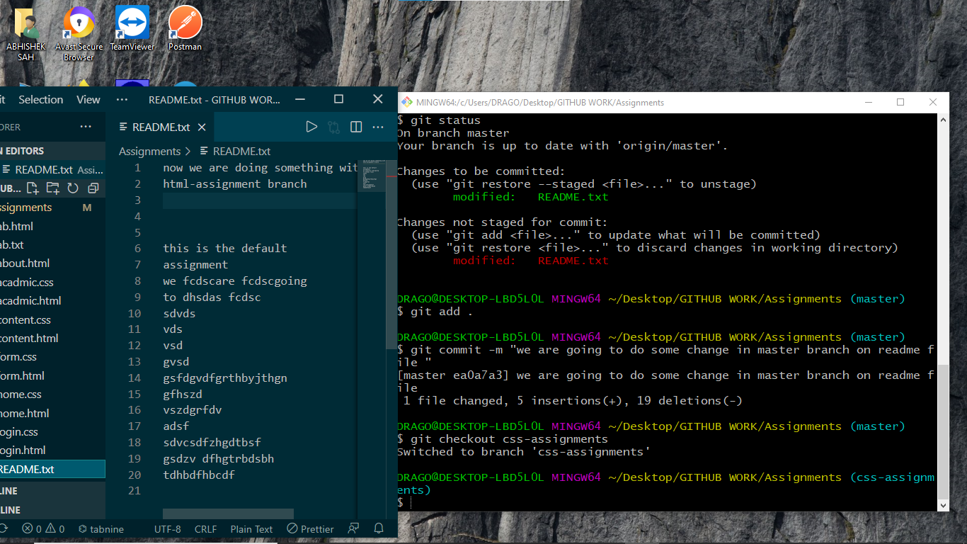

**10. Make minor changes into few files belonging to ‘css-assignments’ branch.**

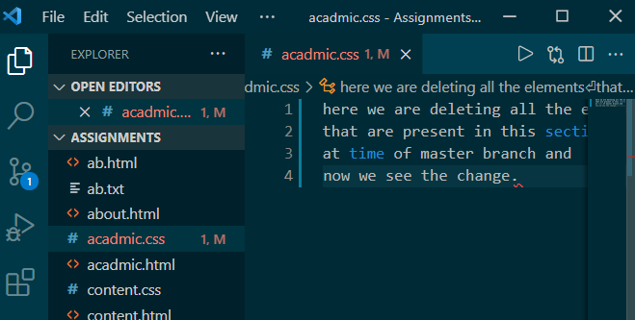

**11. Commit those changes.**

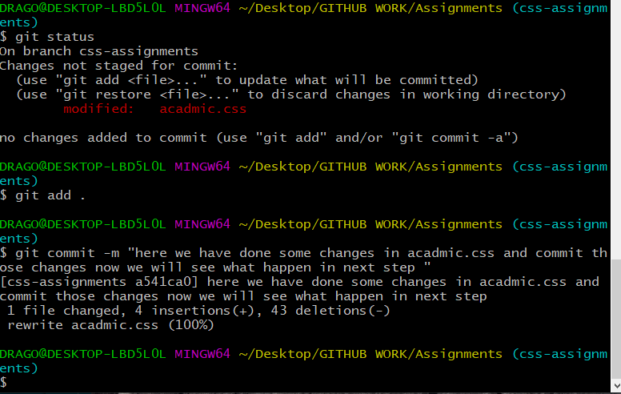

**12. Switch to master.**

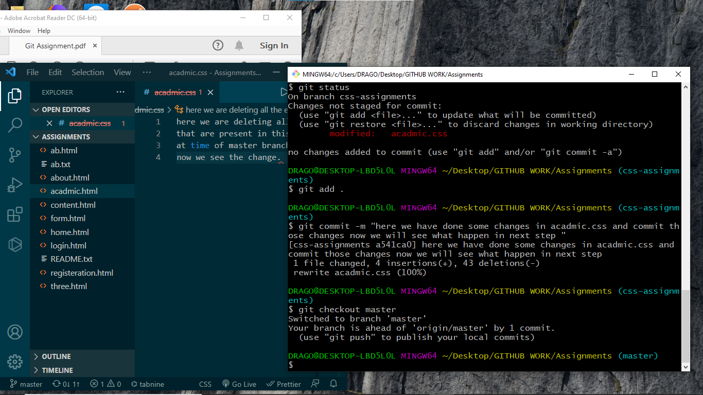

**13. Merge ‘css-assignments’ branch into master. Confirm all css assignments are shown in master.**

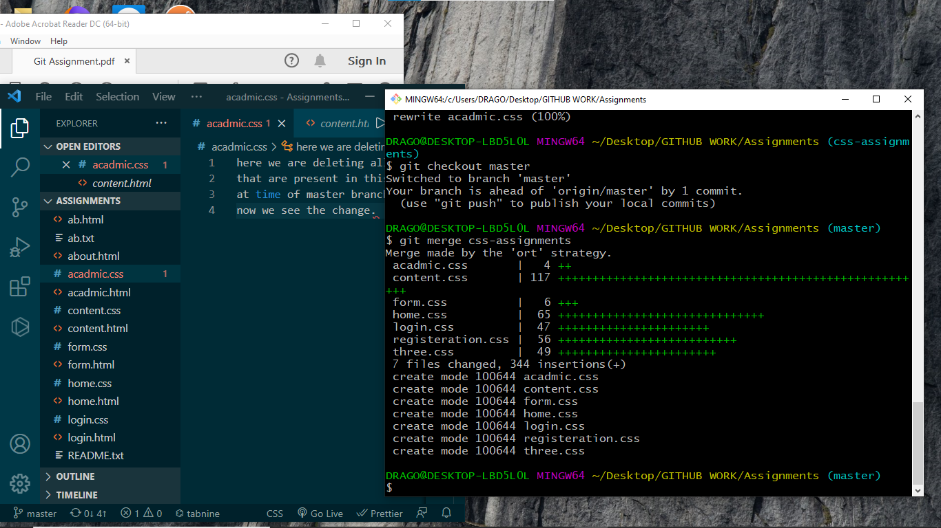

**14. Finally delete the ‘css-assignments’ branch.**

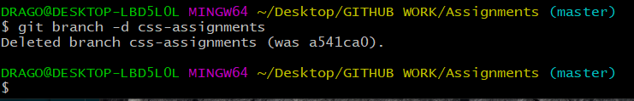

**SECTION-3 - (JavaScript assignments) Steps to follow:**

**1. Create a new branch ‘js-assignments’.**

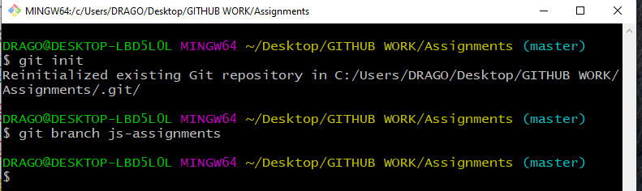

**2. Switch to ‘js-assignments’ branch.**

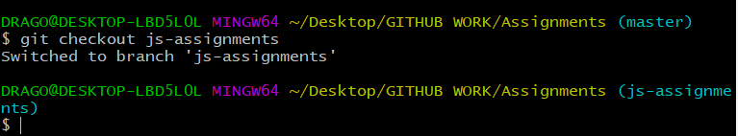

**3. Copy all JavaScript assignments inside ‘Assignments’ folder.**

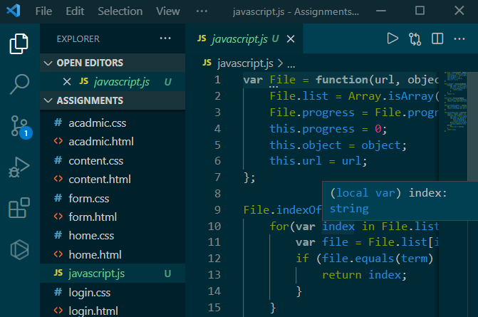

**4. Commit JavaScript assignments into ‘js-assignments’ branch.**

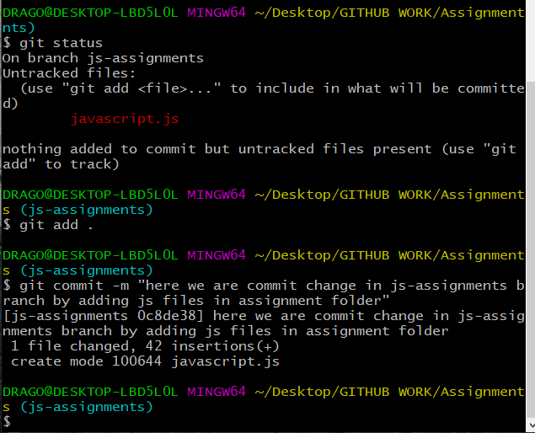

**5. Make minor changes into README.txt file on line 1 belonging to ‘js-assignments’ branch.**

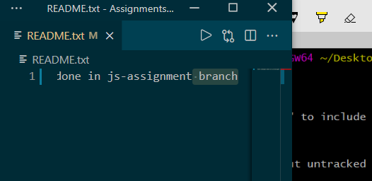

**6. Commit those changed files.**

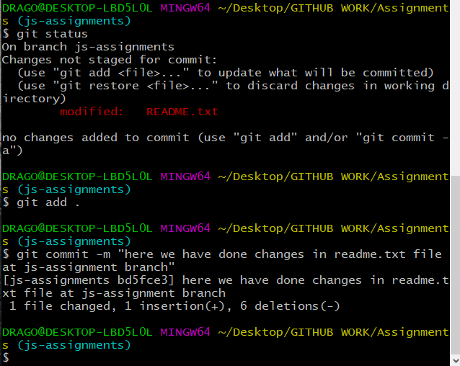

**7. Switch to master branch.**

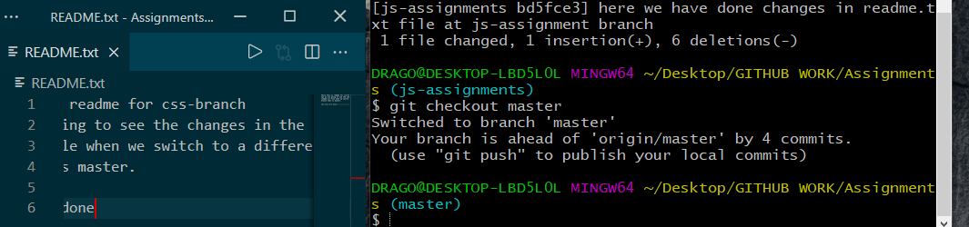

**8. Make minor changes into README.txt file on line 1 & commit those changes into master.**

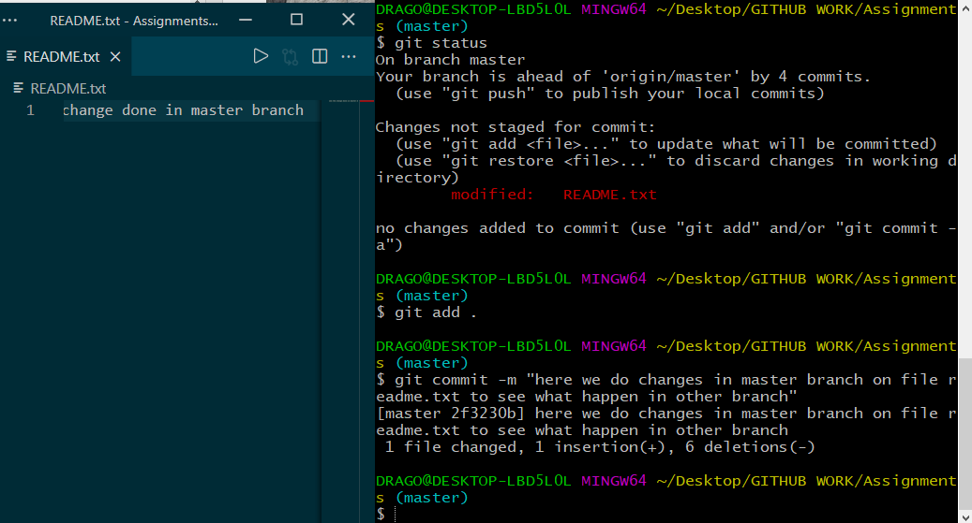

**9. Again switch to ‘js-assignments’ branch.**

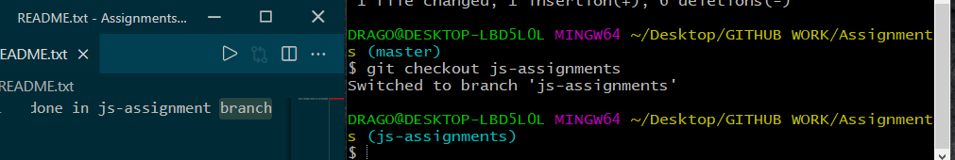

**10. Make minor changes into few files belonging to ‘js-assignments’ branch.**

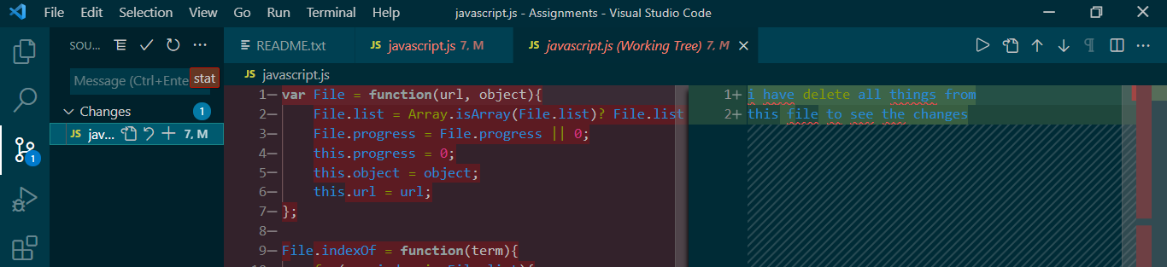

**11. Commit those changes.**

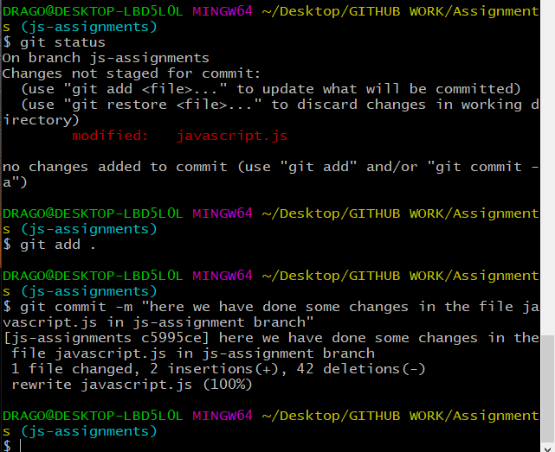

**12. Switch to master.**

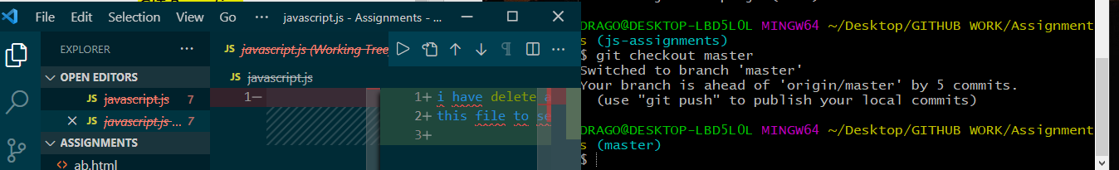

**13. Merge ‘js-assignments’ branch into master. Confirm all JavaScript assignments are shown in master.**

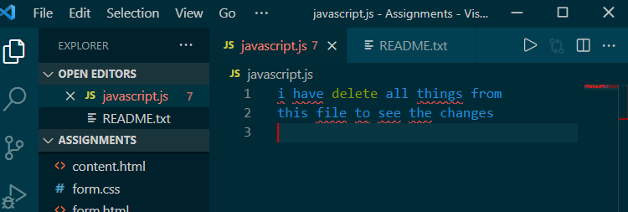

**14. Finally delete the ‘js-assignments’ branch.**

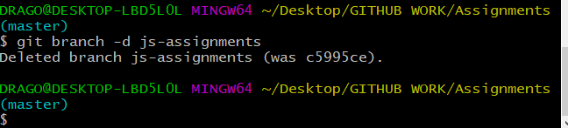

***GIT Remoting***

**Objective: Pushing source code into GITHUB & collaborate team members.**

**SECTION-1 (Pushing assignments to remote repository) - Steps to follow:**

**39. Create a github account if you do not have already.**

**40. Login on into github account.**

**41. Create new public repository ‘freshersbatch-oct16’.**

**42. Commit & push any sample file to this repository under ‘Assignments’ directory.**

**SECTION-2 (Pushing source code to remote repository using Eclipse GIT plugin) - Steps to follow:**

**1. One developer from project team will create eclipse projects ‘SampleProj’ & add sample source code files. Then commit all files through eclipse GIT plugin.**

**2. Collaborate other team members with your github account so that they can also modify the committed files.**

**3. Other developers from same team will checkout all files from remote repository. This might get conflicts since certain files fail to merge. In such case, merge it manually.**

**4. Commit & push the ‘SampleProj’ project.**